# 

|  |  |
| --- | --- |
| Name | **BLESSY JOHN** |
| Topic | **Book Shop Management System** |
| Employee ID | **8133353** |
| Email ID | **blessyjohn@virtusa.com** |

SPECIFICATIONS 3

ABSTRACT 4

MODULES 4

Admin Module 4

Seller Module 4

SCOPE 5

ERDIAGRAM 5

TABLES 6&7

# 

# SPECIFICATIONS

|  |  |
| --- | --- |
| **Title of the Project** | **Book Shop Management System** |
| **Software Requirements** | **Operating System :** Windows 10 or 11  **Database Server:** Microsoft SQL Server Management Studio 18  **Client:** Microsoft edge, Chrome, Firefox,  **Tools:** Microsoft Visual Studio 2022 , .Net framework 4.8  **Frontend:** HTML, CSS, ASP.NET, Bootstrap  **Backend**: C#, ADO.NET |
| **Hardware Requirements** | **Processor:** Intel core i3 or more  **Ram:** 8 GB Ram or more |

# 

# ABSTRACT

Book Shop Management System aims to automate all kind of

activities in a Bookshop and manage the books.

This would be useful to update,delete and add new books and

also categorizes books based on different categories and authors

which is helpful for proper management of books

# MODULES

1. Admin Module
2. Seller Module

# Admin Module

* The Admin module helps in the following operations:
* Manage all the book details.Admin can add new books,

update a book detail and also delete book information from

the list.

* Stores all Book information based on different categories

and authors

* The admin can add new categories of books which divides

all the books based on categories and helps in easy management of books.

* The admin can add different authors and details of the

authors

* The admin aso add the details of the seller

# Seller Module

# The Seller gets into the website with his/her emailand the following operations can be done

# The site contains all the details of the book available

* The Seller can select the item needed and the quantity required and add it to the client’s bill
* The Number of books gets reduced as each books get sold

# SCOPE

The scope of this document is limited to addressing the requirements from a user,quality,and non-functional perspective

**E-R DIAGRAM(FLOWCHART)**

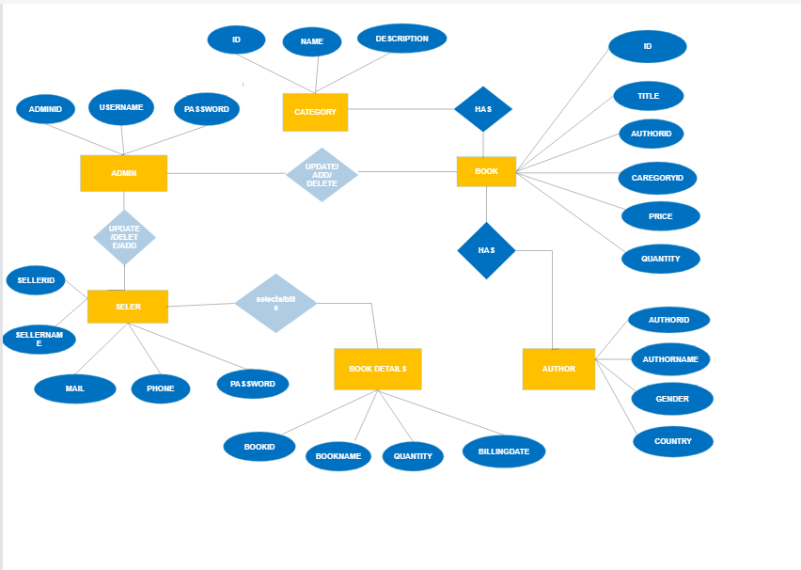

**TABLES**

**ADMIN**

|  |  |
| --- | --- |
| ADMINID | INT  (PRIMARY KEY) |
| USERNAME | VARCHAR(50) |
| PASSWORD | VARCHAR(50) |

**BOOK**

|  |  |
| --- | --- |
| ID | INT  (PRIMARY KEY) |
| TITLE | VARCHAR(50) |
| AUTHORID | VARCHAR(50)  (FOREIGN KEY) |
| CATEGORYID | VARCHAR(50)  (FOREIGN KEY) |
| PRICE | INT |
| QUANTITY | INT |

**CATEGORY**

|  |  |
| --- | --- |
| CATEGORYID | INT(PRIMARY KEY) |
| NAME | VARCHAR(50) |
| DESCRIPTION | VARCHAR(100) |

**AUTHOR**

|  |  |
| --- | --- |
| AUTHORID | INT(PRIMARY KEY) |
| AUTHORNAME | VARCHAR(50) |
| GENDER | CHAR(10) |
| COUNTRY | VARCHAR(25) |

**SELLER**

|  |  |
| --- | --- |
| SELLERID | INT  (PRIMARY KEY) |
| SELLERNAME | VARCHAR(50) |
| MAIL | VARCHAR(50) |
| PHONE | VARCHAR(50) |
| PASSWORD | VARCHAR(50) |

**BOOK ID**

|  |  |
| --- | --- |
| BOOKID | INT(FOREIGN KEY) |
| BOOKNAME | VARCHAR(25) |
| QUANTITY | INT |
| BILLINGDATE | DATE |